17 Creating a Bouncing Slime
Contents
Beginning the Process of Coding 3
Object Controller Create Event 3
Script - Regenerate Maze Function 6
A Script to spawn the Slimes in the Maze 9
The Blue Slime Object 11
How to Control the slime generation 14

In this tutorial, we want to create a smaller bouncing slime that we can have inside of the dungeon. Right now, we had been temporarily using the same slime that we were using inside the fight room, but this look, for our slime in the dungeon looks a bit over whelming. So, if we are going to resize this thing, why not animate it a bit to do some bouncing inside the dungeon.
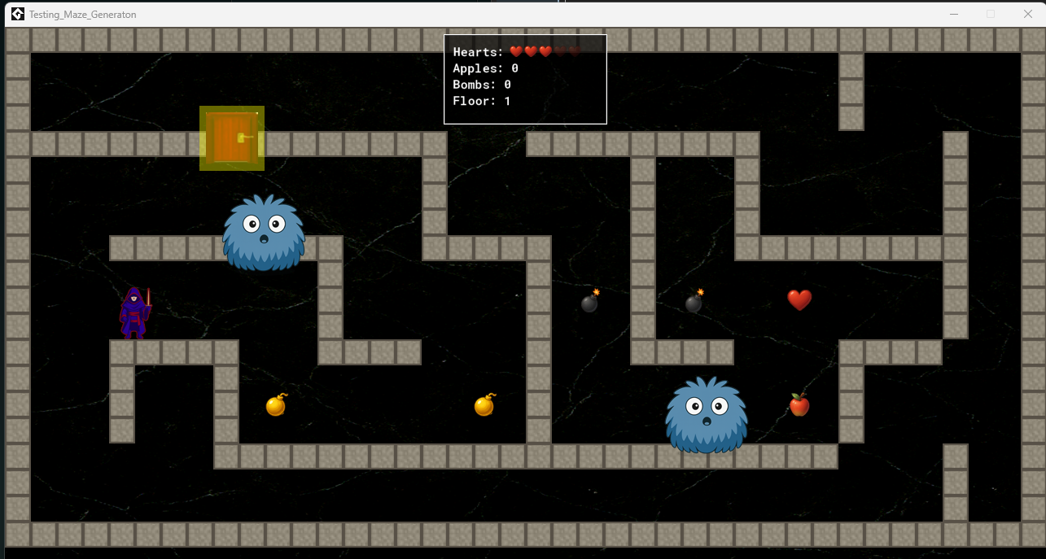
We could of course keep him that size, but I would rather have some symmetry between the hero and the enemy in the halls of the dungeon.
So, we will look at shrinking him down to a size of 64px X 64px.
Inside the slime folder, create another folder named something like dungeon Bounce.
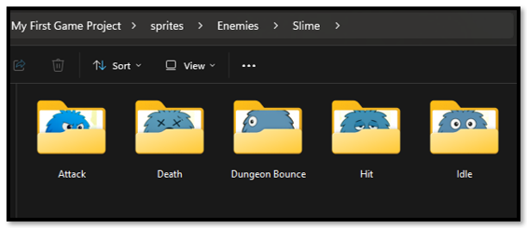
Inside this Dungeon Bounce folder, create another 4 folders for each direction that the enemy will travel inside of the maze.

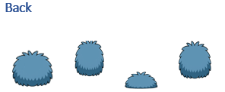

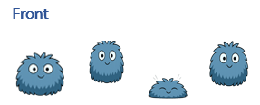
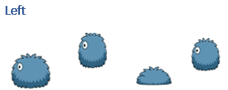

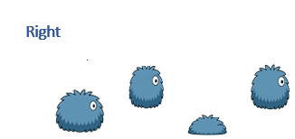
Note -Remember to remove the original enemy Slimes that you placed in the dungeon, or you will have the big slimes and the small slimes in there

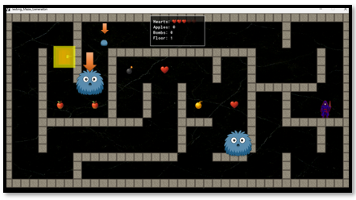

Beginning the Process of Coding
Naming used:
Sprites
  - spr_blue_bouncing_slime_up
  - spr_blue_bouncing_slime_down
  - spr_blue_bouncing_slime_left
  - spr_blue_bouncing_slime_right

Object
  - obj_blue_bouncing_directional_slime
Script
  - spawn_maze_slimes
  - Add to: scr_regenerate_maze

Object Controller Create Event
Open the Object Controller,
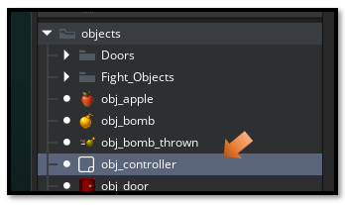
Write this Code inside of the Create Event.
//~~~~~~~~~~ CONTROLLER OBJECT CREATE EVENT ~~~~~~~~~~~~~~~~~~~~~~~~
// Integrates item system with maze generation
// for 1280x704 room size

// STEP 1: INITIALIZE ITEM SYSTEM

show_debug_message("=== INITIALIZING ITEM SYSTEM ===");

global.hearts = 3; // Starting lives
global.max_hearts = 5; // Maximum hearts
global.apples = 0; // Gysahi Greens counter
global.bombs_held = 0; // Bombs in inventory
global.current_floor = 1; // Current dungeon floor
global.hero_start_x = 0; // Will be saved after spawn
global.hero_start_y = 0; // Will be saved after spawn
global.in_fight = false; // Initialize fight state flag

show_debug_message("Hearts: " + string(global.hearts) + "/" + string(global.max_hearts));
show_debug_message("Floor: " + string(global.current_floor));
show_debug_message("=== ITEM SYSTEM READY ===");

// STEP 2: GENERATE MAZE (Your existing code)

var target_width = 1280;
var target_height = 704;
var cell_size = 128;

var maze_width = floor(target_width / cell_size);
var maze_height = floor(target_height / cell_size);

show_debug_message("=== CREATING MAZE FOR NEW ROOM SIZE ===");
show_debug_message("Room dimensions: " + string(target_width) + " x " + string(target_height));
show_debug_message("Creating maze: " + string(maze_width) + " x " + string(maze_height) + " cells");
show_debug_message("Cell size: " + string(cell_size) + "px");
show_debug_message("Wall size: 32px");

var time_seed = get_timer();
random_set_seed(time_seed);
show_debug_message("Random seed set to: " + string(time_seed));
show_debug_message("Testing random values: " + string(irandom(100)) + ", " + string(irandom(100)) + ", " + string(irandom(100)));

// Create and generate the maze
global.myMaze = new maze("recursive_backtrack", maze_width, maze_height);
maze_generate(global.myMaze);

// Spawn the maze walls
spawn_maze_walls(global.myMaze, cell_size, 0, 0);

// Spawn hero and door
spawn_object_in_opening(global.myMaze.heroWallSide, global.myMaze.heroPosition, cell_size, global.myMaze.w, global.myMaze.h, object_hero, "Hero");
spawn_object_in_opening(global.myMaze.doorWallSide, global.myMaze.doorPosition, cell_size, global.myMaze.w, global.myMaze.h, obj_door, "Door");

show_debug_message("=== MAZE SETUP COMPLETE ===");

// STEP 3: SAVE HERO STARTING POSITION

show_debug_message("=== SAVING HERO START POSITION ===");

var hero = instance_find(object_hero, 0);
if (hero != noone) {
global.hero_start_x = hero.x;
global.hero_start_y = hero.y;

show_debug_message("Hero start position saved: (" + string(global.hero_start_x) + ", " + string(global.hero_start_y) + ")");
} else {
show_debug_message("WARNING: Could not find hero to save position!");
}

// STEP 3.5: SPAWN MAZE SLIME

var slimes_to_spawn = 1;
spawn_maze_slimes(global.myMaze, cell_size, obj_blue_bouncing_directional_slime, slimes_to_spawn);

// STEP 4: SPAWN ITEMS IN MAZE

// Balanced spawning: 1-2 of each item type

// Random amount between 1-2 for each item
var hearts_to_spawn = irandom_range(1, 2);
var apples_to_spawn = irandom_range(1, 2);
var bombs_to_spawn = irandom_range(1, 2);
var hazards_to_spawn = irandom_range(1, 2); // 1-2 hazard bombs (guaranteed spawn)

spawn_guaranteed_items(global.myMaze, cell_size, hearts_to_spawn, apples_to_spawn, bombs_to_spawn, hazards_to_spawn);

// Alternative methods (comment out the above and uncomment one of these):
// OPTION 1: Pure random spawning (adjust spawn_chance in function)
// spawn_items_in_maze(global.myMaze, cell_size);

// OPTION 2: Fixed exact counts (hearts, apples, good bombs, hazard bombs)
// spawn_guaranteed_items(global.myMaze, cell_size, 2, 2, 2, 1);

show_debug_message("=== DUNGEON FLOOR " + string(global.current_floor) + " READY ===");

Script - Regenerate Maze Function
Open this script inside of your Scripts folder in the Asset Browser
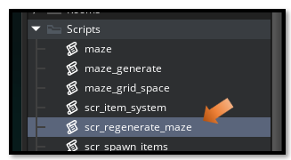

You will need to write this script. Remember, a script will not have any events associated with it, you merely open the Script file and write your code. We have this regenerate maze script already, we will just add to it the addition of the new dungeon bouncing slime.

// ~~~~~~~~~~~~~~ REGENERATE MAZE FUNCTION ~~~~~~~~~~~~~~
// Call this function to regenerate the maze without restarting the room
// This preserves all global variables (treasures, floor number, etc.)
// Uses your existing maze generation system

function regenerate_maze() {
show_debug_message("=== REGENERATING MAZE ===");
show_debug_message("Floor: " + string(global.current_floor));
show_debug_message("Hearts: " + string(global.hearts) + ", Apples: " + string(global.apples) + ", Bombs: " + string(global.bombs_held));

// ========================================================================
// STEP 1: Clean up existing maze objects
// ========================================================================
show_debug_message("Destroying old maze objects...");

// Destroy walls
with (obj_wall_plain) { instance_destroy(); }
with (obj_wall_crackedA) { instance_destroy(); }
with (obj_wall_crackedB) { instance_destroy(); }

// Destroy items
with (obj_heart) { instance_destroy(); }
with (obj_apple) { instance_destroy(); }
with (obj_bomb) { instance_destroy(); }
with (obj_hazard_bomb) { instance_destroy(); } // Fixed name!

// Destroy door and thrown bombs
with (obj_door) { instance_destroy(); }
with (obj_bomb_thrown) { instance_destroy(); }

// Destroy maze slimes
with (obj_blue_bouncing_directional_slime) { instance_destroy(); }

show_debug_message("Old objects destroyed.");

// ========================================================================
// STEP 2: Generate new maze using existing system
// ========================================================================
show_debug_message("Generating new maze...");

var target_width = 1280;
var target_height = 704;
var cell_size = 128;
var maze_width = floor(target_width / cell_size);
var maze_height = floor(target_height / cell_size);

// New random seed
var time_seed = get_timer();
random_set_seed(time_seed);

// Use your existing maze generation system
global.myMaze = new maze("recursive_backtrack", maze_width, maze_height);
maze_generate(global.myMaze);
spawn_maze_walls(global.myMaze, cell_size, 0, 0);

// ========================================================================
// STEP 3: Reposition hero and spawn door
// ========================================================================
spawn_object_in_opening(global.myMaze.heroWallSide, global.myMaze.heroPosition, cell_size, global.myMaze.w, global.myMaze.h, object_hero, "Hero");
spawn_object_in_opening(global.myMaze.doorWallSide, global.myMaze.doorPosition, cell_size, global.myMaze.w, global.myMaze.h, obj_door, "Door");

// Update hero start position
var hero = instance_find(object_hero, 0);
if (hero != noone) {
global.hero_start_x = hero.x;
global.hero_start_y = hero.y;
}

// STEP 3.5: Spawn maze slimes
var slimes_to_spawn = 1;
spawn_maze_slimes(global.myMaze, cell_size, obj_blue_bouncing_directional_slime, slimes_to_spawn);

// ========================================================================
// STEP 4: Spawn items using existing system
// ========================================================================
var hearts_to_spawn = irandom_range(1, 2);
var apples_to_spawn = irandom_range(1, 2);
var bombs_to_spawn = irandom_range(1, 2);
var hazards_to_spawn = irandom_range(0, 2);

spawn_guaranteed_items(global.myMaze, cell_size, hearts_to_spawn, apples_to_spawn, bombs_to_spawn, hazards_to_spawn);

show_debug_message("=== MAZE REGENERATION COMPLETE ===");
show_debug_message("Now on Floor " + string(global.current_floor));
}

A Script to spawn the Slimes in the Maze
Now this is going to be a brand-new script and it will be used to automatically create the slimes in the maze. This will prevent these slimes from just popping up in weird places like on top of the walls. Since our maze is self – generating, we have no idea where the walls will show up, so it just make sense to let the system take over and automatically take over the placement of these critters.

// ~~~~~~~~~ SPAWN MAZE SLIMES - Standalone Script ~~~~~~~~~~~~~~~~~~
// Create a script in GameMaker called "spawn_maze_slimes"
// Spawns a set number of slimes in open maze cells

function spawn_maze_slimes(_mazeStruct, _cellSize, _objectType, _count) {
show_debug_message("=== SPAWNING MAZE SLIMES ===");
show_debug_message("Count: " + string(_count));

var m = _mazeStruct;
var cell_size = _cellSize;

var spawn_positions = ds_list_create();

for (var i = 1; i < m.w - 1; i++) {
for (var j = 1; j < m.h - 1; j++) {
var pos_x = i * cell_size + (cell_size / 2);
var pos_y = j * cell_size + (cell_size / 2);

var hero = instance_find(object_hero, 0);
var door = instance_find(obj_door, 0);

var too_close = false;
var min_distance = 180;

if (hero != noone && point_distance(pos_x, pos_y, hero.x, hero.y) < min_distance) {
too_close = true;
}
if (door != noone && point_distance(pos_x, pos_y, door.x, door.y) < min_distance) {
too_close = true;
}

if (!too_close && !position_meeting(pos_x, pos_y, obj_wall_plain) &&
!position_meeting(pos_x, pos_y, obj_wall_crackedA) &&
!position_meeting(pos_x, pos_y, obj_wall_crackedB)) {
ds_list_add(spawn_positions, [pos_x, pos_y, i, j]);
}
}
}

show_debug_message("Valid slime spawn positions: " + string(ds_list_size(spawn_positions)));

ds_list_shuffle(spawn_positions);

var placed = 0;
var max_place = min(_count, ds_list_size(spawn_positions));

for (var s = 0; s < max_place; s++) {
var pos = spawn_positions[| s];
instance_create_layer(pos[0], pos[1], "Instances", _objectType);
show_debug_message("Placed slime at cell [" + string(pos[2]) + ", " + string(pos[3]) + "]");
placed++;
}

ds_list_destroy(spawn_positions);

show_debug_message("Total slimes placed: " + string(placed));
show_debug_message("=== MAZE SLIME SPAWNING COMPLETE ===");
}

The Blue Slime Object
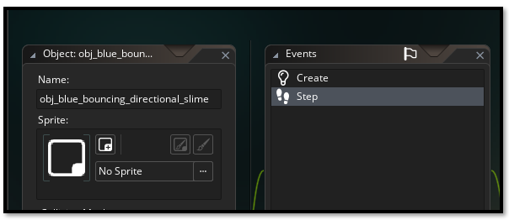

Your blue slime object will have these events associated with it.

- The Create Event
- The Step Event

// ~~~~~~ obj_blue_bouncing_directional_slime - CREATE EVENT ~~~~~~~~~
// obj_blue_bouncing_directional_slime - CREATE EVENT
// Small maze slime setup (directional bounce)

move_speed = 2;
lunge_speed = 10;
lunge_distance = 192;
lunge_align_tolerance = 48;
lunge_align_speed = 2;
lunge_time_max = 20;
lunge_timer = 0;
lunge_windup_max = 12;
lunge_windup = 0;
lunge_pending = false;
lunge_dir = 0;
lunge_target_x = 0;
lunge_target_y = 0;
lunge_cooldown_max = 60;
lunge_cooldown = 0;
move_dir = choose(0, 90, 180, 270);

sprite_up = spr_blue_bouncing_slime_up;
sprite_down = spr_blue_bouncing_slime_down;
sprite_left = spr_blue_bouncing_slime_left;
sprite_right = spr_blue_bouncing_slime_right;

sprite_index = sprite_down;
image_speed = 0.2;

image_xscale = 0.5;
image_yscale = 0.5;

// ~~~~~~ obj_blue_bouncing_directional_slime - STEP EVENT ~~~~~~~~~~~
// obj_blue_bouncing_directional_slime - STEP EVENT
// Bounce through maze hallways and switch sprites by direction

var hero = instance_find(object_hero, 0);

if (lunge_cooldown > 0) lunge_cooldown--;
if (lunge_timer > 0) lunge_timer--;
if (lunge_windup > 0) {
lunge_windup--;
if (lunge_windup == 0 && lunge_pending) {
move_dir = lunge_dir;
lunge_timer = lunge_time_max;
lunge_cooldown = lunge_cooldown_max;
lunge_pending = false;
}
}

if (lunge_windup > 0 && lunge_pending) {
if (lunge_dir == 90 || lunge_dir == 270) {
var align_dx = clamp(lunge_target_x - x, -lunge_align_speed, lunge_align_speed);
if (!place_meeting(x + align_dx, y, obj_wall_plain) &&
!place_meeting(x + align_dx, y, obj_wall_crackedA) &&
!place_meeting(x + align_dx, y, obj_wall_crackedB)) {
x += align_dx;
}
} else {
var align_dy = clamp(lunge_target_y - y, -lunge_align_speed, lunge_align_speed);
if (!place_meeting(x, y + align_dy, obj_wall_plain) &&
!place_meeting(x, y + align_dy, obj_wall_crackedA) &&
!place_meeting(x, y + align_dy, obj_wall_crackedB)) {
y += align_dy;
}
}
}

if (hero != noone && lunge_timer <= 0 && lunge_cooldown <= 0 && lunge_windup <= 0 && !lunge_pending) {
var dist_to_hero = point_distance(x, y, hero.x, hero.y);
if (dist_to_hero <= lunge_distance) {
var blocked_line = collision_line(x, y, hero.x, hero.y, obj_wall_plain, false, true) ||
collision_line(x, y, hero.x, hero.y, obj_wall_crackedA, false, true) ||
collision_line(x, y, hero.x, hero.y, obj_wall_crackedB, false, true);
if (!blocked_line) {
var dx = hero.x - x;
var dy = hero.y - y;
var aligned_h = abs(dy) <= lunge_align_tolerance;
var aligned_v = abs(dx) <= lunge_align_tolerance;

if (aligned_h || aligned_v) {
if (aligned_h && !aligned_v) {
lunge_dir = (dx > 0) ? 0 : 180;
} else if (aligned_v && !aligned_h) {
lunge_dir = (dy > 0) ? 270 : 90;
} else {
lunge_dir = (abs(dx) > abs(dy)) ? ((dx > 0) ? 0 : 180) : ((dy > 0) ? 270 : 90);
}
lunge_target_x = hero.x;
lunge_target_y = hero.y;
lunge_windup = lunge_windup_max;
lunge_pending = true;
} else {
var align_dir;
if (abs(dx) > abs(dy)) {
align_dir = (dy > 0) ? 270 : 90;
} else {
align_dir = (dx > 0) ? 0 : 180;
}

var align_blocked = false;
if (align_dir == 0) {
align_blocked = place_meeting(x + move_speed, y, obj_wall_plain) ||
place_meeting(x + move_speed, y, obj_wall_crackedA) ||
place_meeting(x + move_speed, y, obj_wall_crackedB);
} else if (align_dir == 180) {
align_blocked = place_meeting(x - move_speed, y, obj_wall_plain) ||
place_meeting(x - move_speed, y, obj_wall_crackedA) ||
place_meeting(x - move_speed, y, obj_wall_crackedB);
} else if (align_dir == 90) {
align_blocked = place_meeting(x, y - move_speed, obj_wall_plain) ||
place_meeting(x, y - move_speed, obj_wall_crackedA) ||
place_meeting(x, y - move_speed, obj_wall_crackedB);
} else if (align_dir == 270) {
align_blocked = place_meeting(x, y + move_speed, obj_wall_plain) ||
place_meeting(x, y + move_speed, obj_wall_crackedA) ||
place_meeting(x, y + move_speed, obj_wall_crackedB);
}

if (!align_blocked) {
move_dir = align_dir;
}
}
}
}
}

var current_speed = (lunge_windup > 0) ? 0 : ((lunge_timer > 0) ? lunge_speed : move_speed);

var hsp = 0;
var vsp = 0;

switch (move_dir) {
case 0: hsp = current_speed; break; // right
case 180: hsp = -current_speed; break; // left
case 90: vsp = -current_speed; break; // up
case 270: vsp = current_speed; break; // down
}

var blocked = place_meeting(x + hsp, y + vsp, obj_wall_plain) ||
place_meeting(x + hsp, y + vsp, obj_wall_crackedA) ||
place_meeting(x + hsp, y + vsp, obj_wall_crackedB);

if (blocked) {
var options = [];

var open_right = !(place_meeting(x + current_speed, y, obj_wall_plain) ||
place_meeting(x + current_speed, y, obj_wall_crackedA) ||
place_meeting(x + current_speed, y, obj_wall_crackedB));
if (open_right) array_push(options, 0);

var open_left = !(place_meeting(x - current_speed, y, obj_wall_plain) ||
place_meeting(x - current_speed, y, obj_wall_crackedA) ||
place_meeting(x - current_speed, y, obj_wall_crackedB));
if (open_left) array_push(options, 180);

var open_up = !(place_meeting(x, y - current_speed, obj_wall_plain) ||
place_meeting(x, y - current_speed, obj_wall_crackedA) ||
place_meeting(x, y - current_speed, obj_wall_crackedB));
if (open_up) array_push(options, 90);

var open_down = !(place_meeting(x, y + current_speed, obj_wall_plain) ||
place_meeting(x, y + current_speed, obj_wall_crackedA) ||
place_meeting(x, y + current_speed, obj_wall_crackedB));
if (open_down) array_push(options, 270);

if (array_length(options) > 0) {
move_dir = options[irandom(array_length(options) - 1)];
} else {
move_dir = (move_dir + 180) mod 360;
}
} else {
x += hsp;
y += vsp;
}

if (move_dir == 0) {
sprite_index = sprite_right;
} else if (move_dir == 180) {
sprite_index = sprite_left;
} else if (move_dir == 90) {
sprite_index = sprite_up;
} else if (move_dir == 270) {
sprite_index = sprite_down;
}

Hero Object
Open up the Hero object, we need to make some changes to the collision event with the hero.
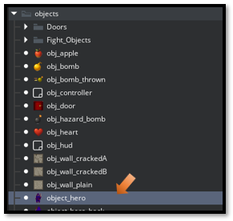

//~~~~~~~~~~ HERO STEP EVENT ~~~~~~~~~~~~~~~~~~~~~~~~
// Includes item collection, damage handling, and bomb throwing

// ============================================================================
// MOVEMENT INPUT (Your existing code)
// ============================================================================
var move_x = keyboard_check(vk_right) - keyboard_check(vk_left);
var move_y = keyboard_check(vk_down) - keyboard_check(vk_up);

var spd = 4;
var dx = move_x * spd;
var dy = move_y * spd;

// ============================================================================
// COLLISION CHECK & MOVEMENT with WALL GLIDING
// ============================================================================
if (dx != 0 || dy != 0) {
// Check full diagonal move
if (!place_meeting(x + dx, y + dy, obj_wall_plain) &&
!place_meeting(x + dx, y + dy, obj_wall_crackedA) &&
!place_meeting(x + dx, y + dy, obj_wall_crackedB)) {
x += dx;
y += dy;
} else {
// Wall gliding: Try to slide along walls smoothly
var moved = false;

// Try horizontal only
if (dx != 0 && !place_meeting(x + dx, y, obj_wall_plain) &&
!place_meeting(x + dx, y, obj_wall_crackedA) &&
!place_meeting(x + dx, y, obj_wall_crackedB)) {
x += dx;
moved = true;
}

// Try vertical only
if (dy != 0 && !place_meeting(x, y + dy, obj_wall_plain) &&
!place_meeting(x, y + dy, obj_wall_crackedA) &&
!place_meeting(x, y + dy, obj_wall_crackedB)) {
y += dy;
moved = true;
}

// If still stuck in wall - AGGRESSIVE AUTO-ESCAPE
if (place_meeting(x, y, obj_wall_plain) ||
place_meeting(x, y, obj_wall_crackedA) ||
place_meeting(x, y, obj_wall_crackedB)) {

show_debug_message("HERO STUCK IN WALL - AUTO ESCAPING!");

// Try to nudge out in 8 directions with larger distance
var nudge_distance = 16; // Increased from 4 to 16
var escaped = false;

for (var angle = 0; angle < 360; angle += 45) {
var nudge_x = lengthdir_x(nudge_distance, angle);
var nudge_y = lengthdir_y(nudge_distance, angle);

if (!place_meeting(x + nudge_x, y + nudge_y, obj_wall_plain) &&
!place_meeting(x + nudge_x, y + nudge_y, obj_wall_crackedA) &&
!place_meeting(x + nudge_x, y + nudge_y, obj_wall_crackedB)) {
x += nudge_x;
y += nudge_y;
escaped = true;
show_debug_message("Hero auto-escaped from wall at angle " + string(angle) + "!");
break;
}
}

// If 16px didn't work, try 32px
if (!escaped) {
show_debug_message("Trying larger escape distance...");
nudge_distance = 32;

for (var angle = 0; angle < 360; angle += 45) {
var nudge_x = lengthdir_x(nudge_distance, angle);
var nudge_y = lengthdir_y(nudge_distance, angle);

if (!place_meeting(x + nudge_x, y + nudge_y, obj_wall_plain) &&
!place_meeting(x + nudge_x, y + nudge_y, obj_wall_crackedA) &&
!place_meeting(x + nudge_x, y + nudge_y, obj_wall_crackedB)) {
x += nudge_x;
y += nudge_y;
escaped = true;
show_debug_message("Hero escaped at 32px distance!");
break;
}
}
}

// Last resort - teleport to calculated safe position
if (!escaped) {
show_debug_message("Could not auto-escape - finding safe location!");

// Calculate center of room as fallback
var safe_x = room_width / 2;
var safe_y = room_height / 2;

// If center is also in wall, try a grid search for ANY safe spot
if (place_meeting(safe_x, safe_y, obj_wall_plain) ||
place_meeting(safe_x, safe_y, obj_wall_crackedA) ||
place_meeting(safe_x, safe_y, obj_wall_crackedB)) {

show_debug_message("Center blocked - searching for safe spot...");
var found_safe = false;

// Search in a grid pattern for a safe spot
for (var check_x = 128; check_x < room_width - 128; check_x += 64) {
for (var check_y = 128; check_y < room_height - 128; check_y += 64) {
if (!place_meeting(check_x, check_y, obj_wall_plain) &&
!place_meeting(check_x, check_y, obj_wall_crackedA) &&
!place_meeting(check_x, check_y, obj_wall_crackedB)) {
safe_x = check_x;
safe_y = check_y;
found_safe = true;
break;
}
}
if (found_safe) break;
}
}

x = safe_x;
y = safe_y;
show_debug_message("Teleported to safe location: (" + string(safe_x) + ", " + string(safe_y) + ")");
}
}
}
}

// ============================================================================
// EMERGENCY ESCAPE SYSTEM
// ============================================================================
// Press R to find a safe position (doesn't rely on spawn being safe)
if (keyboard_check_pressed(ord("R"))) {
show_debug_message("=== EMERGENCY ESCAPE ACTIVATED ===");

// First try the original spawn position
if (!place_meeting(global.hero_start_x, global.hero_start_y, obj_wall_plain) &&
!place_meeting(global.hero_start_x, global.hero_start_y, obj_wall_crackedA) &&
!place_meeting(global.hero_start_x, global.hero_start_y, obj_wall_crackedB)) {
x = global.hero_start_x;
y = global.hero_start_y;
show_debug_message("Returned to spawn: (" + string(x) + ", " + string(y) + ")");
} else {
// Spawn is blocked, find a safe spot
show_debug_message("Spawn blocked - searching for safe location...");

var safe_x = room_width / 2;
var safe_y = room_height / 2;

// If center is also in wall, do a grid search
if (place_meeting(safe_x, safe_y, obj_wall_plain) ||
place_meeting(safe_x, safe_y, obj_wall_crackedA) ||
place_meeting(safe_x, safe_y, obj_wall_crackedB)) {

var found_safe = false;

// Search in a grid pattern for ANY safe spot
for (var check_x = 128; check_x < room_width - 128; check_x += 64) {
for (var check_y = 128; check_y < room_height - 128; check_y += 64) {
if (!place_meeting(check_x, check_y, obj_wall_plain) &&
!place_meeting(check_x, check_y, obj_wall_crackedA) &&
!place_meeting(check_x, check_y, obj_wall_crackedB)) {
safe_x = check_x;
safe_y = check_y;
found_safe = true;
break;
}
}
if (found_safe) break;
}
}

x = safe_x;
y = safe_y;
show_debug_message("Escaped to safe location: (" + string(safe_x) + ", " + string(safe_y) + ")");
}

// Optional: Play a sound effect
// audio_play_sound(snd_teleport, 1, false);
}

// ============================================================================
// DEBUG: FORCE HERO INTO WALL (TEMPORARY - REMOVE AFTER TESTING)
// ============================================================================
// Press T to teleport hero into a wall for testing the escape system
if (keyboard_check_pressed(ord("T"))) {
// Find a wall and teleport hero into it
var test_wall = instance_find(obj_wall_plain, 0);

if (test_wall != noone) {
x = test_wall.x;
y = test_wall.y;
show_debug_message("=== DEBUG: TELEPORTED INTO WALL FOR TESTING ===");
show_debug_message("Position: (" + string(x) + ", " + string(y) + ")");
show_debug_message("Press R to test emergency escape!");
} else {
show_debug_message("No walls found to teleport into.");
}
}

// ============================================================================
// SPRITE SWITCHING (Your existing code)
// ============================================================================
if (move_y < 0) {
sprite_index = sprite_hero_back;
} else if (move_x > 0) {
sprite_index = sprite_hero_right;
} else if (move_x < 0) {
sprite_index = sprite_hero_left;
} else {
sprite_index = sprite_hero;
}

// ============================================================================
// NEW: ITEM COLLECTION
// ============================================================================

// --- Collect Heart ---
var item_heart = instance_place(x, y, obj_heart);
if (item_heart != noone) {
// Heal 1 heart
global.hearts += 1;
if (global.hearts > global.max_hearts) {
global.hearts = global.max_hearts;
}

show_debug_message("Collected heart! Hearts: " + string(global.hearts) + "/" + string(global.max_hearts));
instance_destroy(item_heart);

// Optional: Play sound effect
// audio_play_sound(snd_collect_heart, 1, false);
}

// --- Collect Apple (Gysahi Greens style) ---
var item_apple = instance_place(x, y, obj_apple);
if (item_apple != noone) {
global.apples += 1;

show_debug_message("Collected apple! Total: " + string(global.apples));
instance_destroy(item_apple);

// Optional: Add special effect (like in Chocobo's Dungeon)
// Could heal 1 heart or give temporary speed boost
// audio_play_sound(snd_collect_apple, 1, false);
}

// --- Collect Bomb (Gold pickup) ---
var item_bomb = instance_place(x, y, obj_bomb);
if (item_bomb != noone) {
global.bombs_held += 1;

show_debug_message("Picked up bomb! Total bombs: " + string(global.bombs_held));
instance_destroy(item_bomb);

// Optional: Play sound effect
// audio_play_sound(snd_collect_bomb, 1, false);
}

// ============================================================================
// NEW: BOMB THROWING
// ============================================================================
// Press SPACE to throw a bomb (only in dungeon, not during fights)

if (keyboard_check_pressed(vk_space) && !global.in_fight) {
if (global.bombs_held > 0) {
global.bombs_held -= 1;

// Determine throw direction based on sprite
var throw_direction = 270; // Default: down

if (sprite_index == sprite_hero_back) {
throw_direction = 90; // Throw up
} else if (sprite_index == sprite_hero_right) {
throw_direction = 0; // Throw right
} else if (sprite_index == sprite_hero_left) {
throw_direction = 180; // Throw left
} else {
throw_direction = 270; // Throw down
}

// Create the bomb projectile slightly ahead of hero
var offset_distance = 32; // Spawn bomb 32 pixels ahead
var bomb_x = x + lengthdir_x(offset_distance, throw_direction);
var bomb_y = y + lengthdir_y(offset_distance, throw_direction);

var bomb = instance_create_layer(bomb_x, bomb_y, "Instances", obj_bomb_thrown);
bomb.direction = throw_direction;
bomb.image_angle = throw_direction;

show_debug_message("Threw bomb! Bombs remaining: " + string(global.bombs_held));

// Optional: Play throw sound
// audio_play_sound(snd_throw_bomb, 1, false);
} else {
show_debug_message("No bombs to throw!");
}
}

// ============================================================================
// NEW: CHECK FOR HAZARDS (Black hazard bomb damages you)
// ============================================================================
// obj_hazard_bomb is the BLACK hazard bomb that damages the hero

var hazard_bomb = instance_place(x, y, obj_hazard_bomb);
if (hazard_bomb != noone) {
// Take damage
global.hearts -= 1;

show_debug_message("Hit a black bomb! Lost 1 heart. Hearts remaining: " + string(global.hearts));

// Destroy the hazard
instance_destroy(hazard_bomb);

// Check if hero died
if (global.hearts <= 0) {
show_debug_message("Hero died! Resetting to floor start...");

// Teleport back to start
x = global.hero_start_x;
y = global.hero_start_y;

// Reset hearts
global.hearts = 3;

show_debug_message("Respawned at: (" + string(x) + ", " + string(y) + ")");
show_debug_message("Hearts restored to: " + string(global.hearts));
}

// Optional: Play damage sound and show damage animation
// audio_play_sound(snd_take_damage, 1, false);
}

// ~~~~~~~~~~~~~~~~~ ENEMY COLLISION - TRIGGER FIGHT SCENE ~~~~~~~~~~~
// Check if hero touches any dungeon enemy (maze slime)
if (place_meeting(x, y, obj_blue_bouncing_directional_slime)) {
show_debug_message("=== ENEMY ENCOUNTER! ===");
show_debug_message("Triggering fight scene...");

// Save the current room so we can return after the fight
global.current_room = room;

// Destroy the enemy in the dungeon (so it doesn't respawn)
var enemy = instance_place(x, y, obj_blue_bouncing_directional_slime);
if (enemy != noone) {
instance_destroy(enemy);
}

// Go to the fight room
room_goto(rm_fight);
}

// ============================================================================
// CHECK FOR EXIT (Your existing code)
// ============================================================================
if (place_meeting(x, y, obj_door)) {
show_debug_message("Hero reached the dungeon exit!");
global.current_floor += 1;
show_debug_message("Advancing to floor " + string(global.current_floor));
regenerate_maze(); // NEW - keeps treasures and floor number
}

How to Control the slime generation

I added one slime per floor in the controller create event and in maze regeneration:
obj_controller
Regenerate Maze Function

If you want more than 1 slime per floor, just change slimes_to_spawn in those two files.
If you want them smaller or larger, adjust image_xscale and image_yscale in the Create Event.

